**Lab Practical #05:**

Study the concept of VLAN using packet tracer.

**Practical Assignment #05:**

1. **Implement the different network structures in VLAN and VLAN trunking. Also check connectivity between them using ping command or PDU utility.**
2. Different VLANs configuration setup screenshot. (VLAN example given by lab faculty)

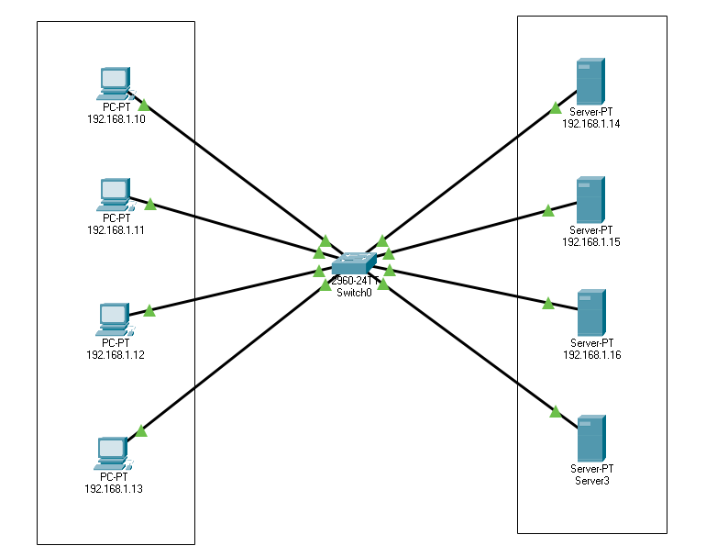

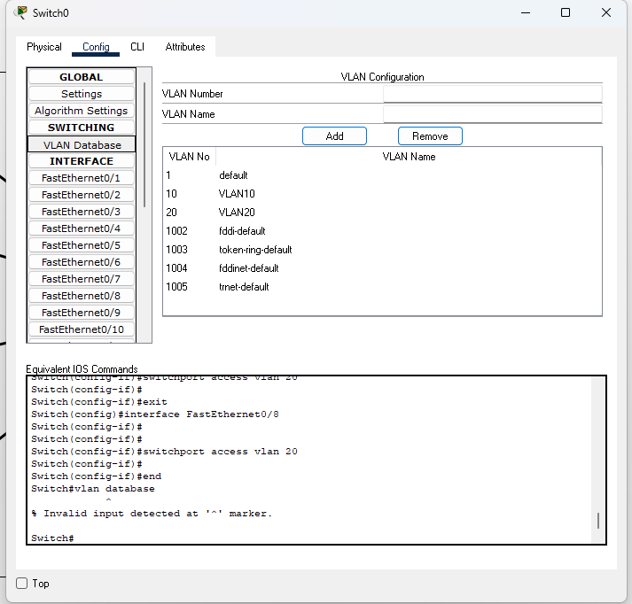

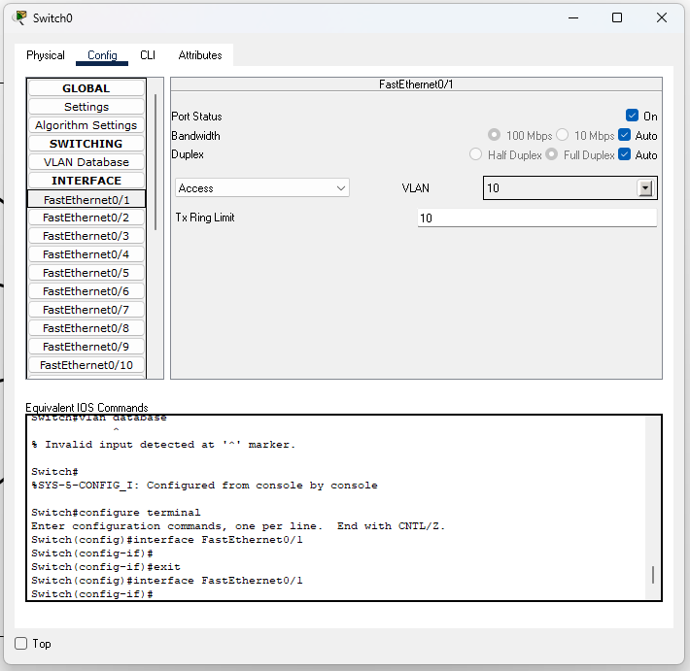

1. Write steps to create VLANs in packet tracer.
2. Open Cisco Packet Tracer

2. Add Network Devices

3. Assign IP Addresses to PCs (Optional)

4. Access the Switch CLI

5. Enter Global Configuration Mode

6. Create VLANs

7. Assign Switch Ports to VLANs

8. Verify VLAN Configuration

1. Mention IP address of each pc as label.

PC1

IP: 192.168.10.10

VLAN 10

PC2

IP: 192.168.10.11

VLAN 10

PC3

IP: 192.168.10.12

VLAN 10

PC4

IP: 192.168.10.13

VLAN 10

Server1

IP: 192.168.10.14

VLAN 20

Server2

IP: 192.168.10.15

VLAN 20

Server3

IP: 192.168.10.16

VLAN 20

Server4

IP: 192.168.10.17

VLAN 20

1. Ping command or PDU screenshot between two VLANs.

